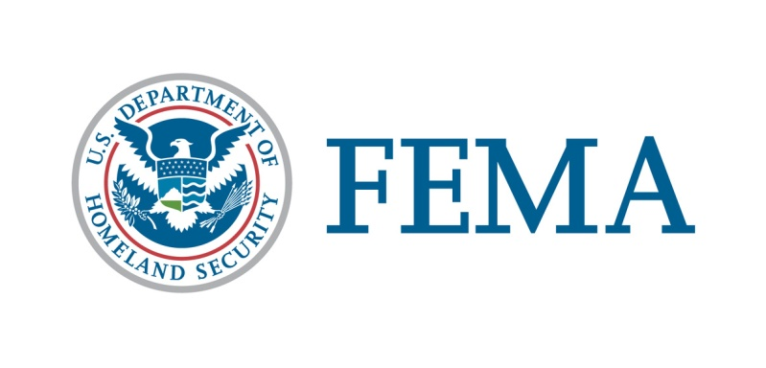

##### Congressional Affairs Division

202-646-4500

**State of Nevada**

**federal disaster declaration fact sheet**

**November 5, 2014**

Today, November 5, 2014, President Obama issued a major disaster declaration for the State of Nevada, triggering the release of Federal funds to help communities recover from the Severe Storms and Flooding that occurred September 7-9, 2014. Details of the disaster declaration and assistance programs are as follows:

Declaration Number: FEMA-4202-DR

Incident: Severe Storms and Flooding

Incident Period: September 7-9, 2014

Federal Coordinating Officer: Mark H. Landry

National FCO Program

Public Assistance (PA): (Assistance for emergency work and the repair or replacement of disaster-damaged facilities):

PA-Designated Area: Moapa Band of Paiutes Reservation

Hazard Mitigation (HM): Assistance for actions taken to prevent or reduce long-term risk to life and property from natural hazards.

HM-Designated Areas: All areas in the State of Nevada are eligible for assistance under the Hazard Mitigation Grant Program.

OTHER: Additional designations may be made at a later date if requested by the State and warranted by the results of further damage assessments.

###